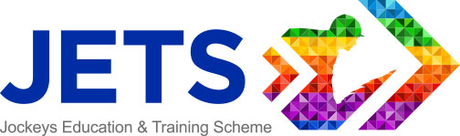
THE JOCKEYS EDUCATION & TRAINING SCHEME
Personal Development Grant Application Form 2023

Please complete this application form to apply for up to £250 contribution towards the cost of an education or training course. This course will contribute to your Personal Development Plan. The full grant amount of £250 can be spread across more than one course or application.
PERSONAL DETAILS
NAME:

ADDRESS:

DATE OF BIRTH:

TELEPHONE: | EMAIL:
TRAINER: | JOCKEY COACH:
RIDES: | WINNERS:
TRAINING COURSE DETAILS
COURSE REQUESTED:
TOTAL COURSE COST:
NAME OF PROVIDER:
CONTACT NAME:
CONTACT TEL:
Why have you chosen this course/training?

How will this course/training contribute to your personal development?

How might this course benefit your professional career?

What other courses or areas can you identify for your future personal or professional development?

I confirm that I am currently licensed and the information I have given is truthful, correct, and complete to the best of my knowledge and belief. I understand that any misleading statements given at any stage of the application process may render this application invalid.

Yes
No

I agree JETS can use my name and course details on their website and on social media.

Please complete the form with as much detail as possible and send to: Phil@jets-uk.org

JETS Office use only

Candidate No: Purchase Order No: Reference:

